SRAM PARAMETER CONTROLLER:
CODE:
`timescale 1ns/1ps
module sram1_controller (
input wire clk,
input wire cs,
input wire we,
input wire rd,
// Low power control
input wire sleep, // sleep mode request
input wire pwr_good, // power status from power gating
input wire [7:0] addr,
input wire [63:0] dataIn,
output reg [63:0] dataOut,
// status outputs
output wire idle,
output wire mem_enable,
output wire clk_gated,
output wire pwr_gate
);
// SRAM Memory
reg [63:0] SRAM [0:255];
// Idle Detection Logic
assign idle = ~ (cs | we | rd);
// Clock Gating Logic
wire clk_en;
assign clk_en = ~sleep & ~idle;
assign clk_gated = clk & clk_en;
// Memory Block Enable
assign mem_enable = cs & ~sleep;
// Power Gating Control
assign pwr_gate = sleep & idle;
// Control signals
wire write_enable;
wire read_enable;
assign write_enable = mem_enable & we & pwr_good;
assign read_enable = mem_enable & rd & pwr_good;
// Write operation
always @ (posedge clk_gated) begin
if (write_enable)
SRAM [addr] <= dataIn;
end
// Read operation
always @ (posedge clk_gated) begin
if (read_enable)
dataOut <= SRAM [addr];
end
endmodule

TEST BENCH CODE:
`timescale 1ns/1ps
module sram1_controller_tb;
// Testbench signals
reg clk;
reg cs;
reg we;
reg rd;
reg sleep;
reg pwr_good;
reg [7:0] addr;
reg [63:0] dataIn;
wire [63:0] dataOut;
wire idle;
wire mem_enable;
wire clk_gated;
wire pwr_gate;
// Instantiate SRAM Controller
sram1_controller uut (
.clk(clk),
.cs(cs),
.we(we),
.rd(rd),
.sleep(sleep),
.pwr_good(pwr_good),
.addr(addr),
.dataIn(dataIn),
.dataOut(dataOut),
.idle(idle),
.mem_enable(mem_enable),
.clk_gated(clk_gated),
.pwr_gate(pwr_gate)
);
// Clock generation
initial begin
clk = 0;
forever #5 clk = ~clk; // 10 ns clock
end
// Test sequence
initial begin
$display("Starting Low Power SRAM Testbench");
cs = 0;
we = 0;
rd = 0;
sleep = 0;
pwr_good = 1;
addr = 0;
dataIn = 0;
// WRITE operation
#10;
cs = 1;
we = 1;
rd = 0;
addr = 8'h10;
dataIn = 64'hAABBCCDDEEFF0011;
#10;
// READ operation
we = 0;
rd = 1;
#10;
$display("Read Data = %h", dataOut);

// IDLE state test
cs = 0;
rd = 0;
we = 0;
#10;
$display("Idle Signal = %b", idle);
// Sleep mode test
sleep = 1;
#10;
$display("Power Gate Signal = %b", pwr_gate);
// Wake up from sleep
sleep = 0;
cs = 1;
we = 1;
addr = 8'h20;
dataIn = 64'h123456789ABCDEF0;
#10;
// Read second value
we = 0;
rd = 1;
#10;
$display("Read Data = %h", dataOut);
// Finish simulation
#20;
$display("Simulation Completed");
$finish;
end
endmodule

SCHEMATIC:

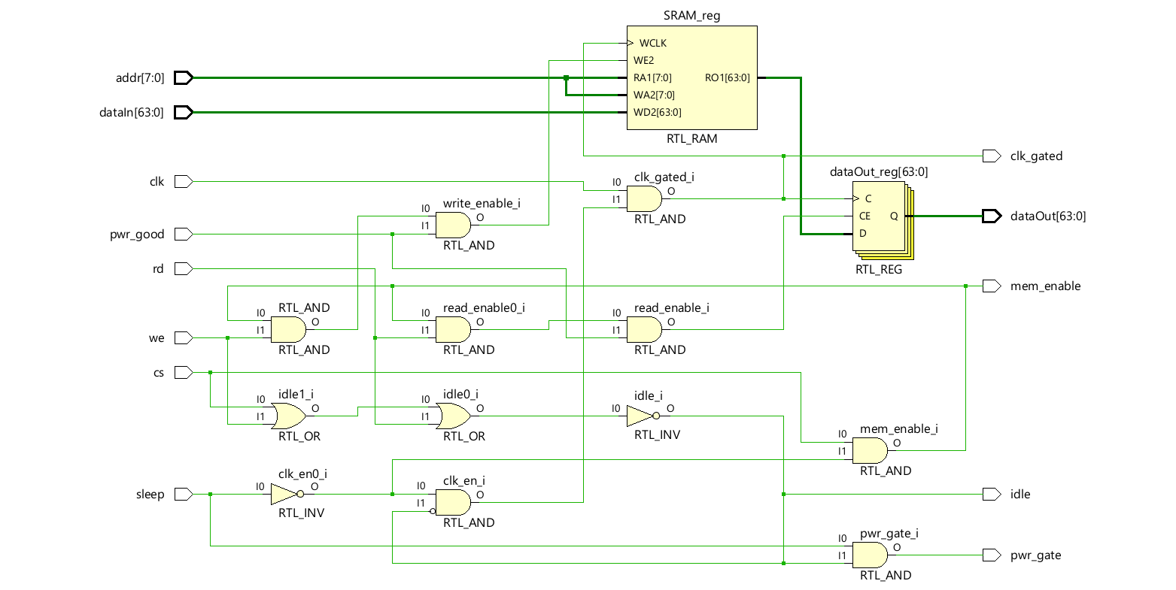
SIMULATION:
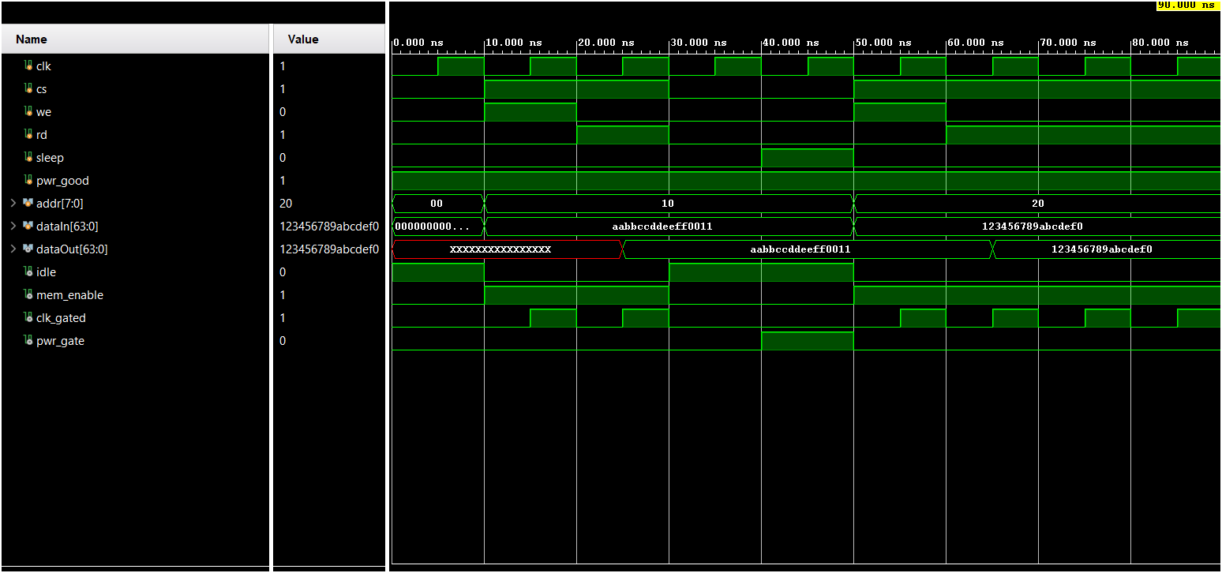

POWER: 5.45 W

